PREREQUISITES

SOFTWARE (PYTHON 3.11.0)

|  |  |
| --- | --- |
| TEAM ID | B2-2M4E |
| PROJECT NAME | SMART WASTE MANAGEMENT SYSTEM FOR METROPOLITAN CITIES |

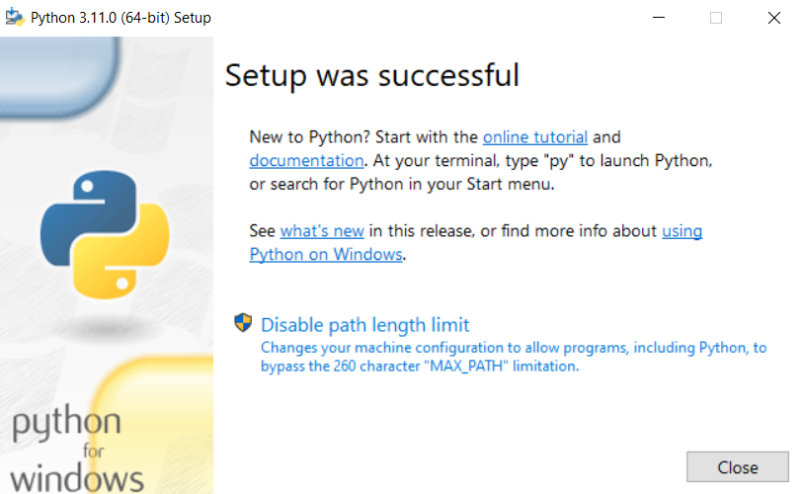

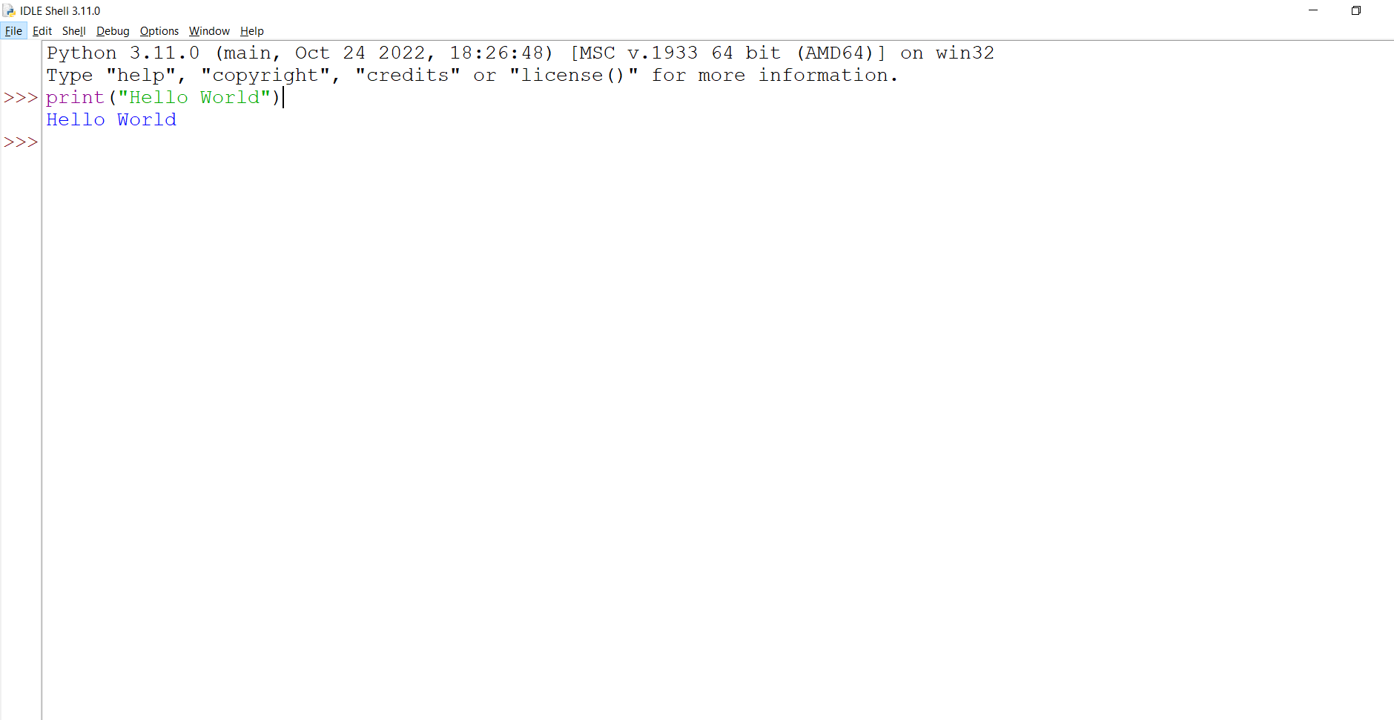

PROGRAM & OUTPUT IN PYTHON IDLE 3.11.0-64BIT

